# File permissions in Linux

## Project description

Examine and manage the permissions of files and directories of users in the research team as the current permissions do not reflect the level of authorization that should be granted. By ensuring all that the users in this group are given the correct permissions it will help keep their data and system secure. The following are screenshots and text explaining how i carried out this project:

## Check file and directory details

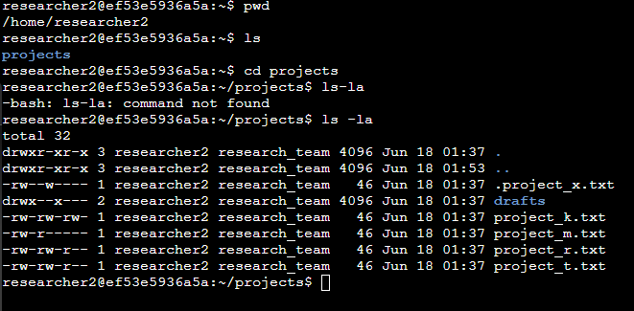

## Describe the permissions string

The permissions string consists of 10 characters which determine the file type and each user’s specific authorization and permissions.

* **1st character:** This character will either be a d or a hyphen (-) and indicates the file type. If the character is a d, it’s a directory. If the character is a hyphen (-) it is a file.
* **2nd-4th characters:** These characters determine the read (r) , write (w), and execute (x), permissions of the user. When one of these characters is a hyphen (-), it indicates that this permission is not granted to the user.
* **5th-7th characters:** These characters determine the read (r) , write (w), and execute (x), permissions for the group. When one of these characters is a hyphen (-), it indicates that this permission is not granted to the group.
* **8th-10th characters:** These characters determine the read (r) , write (w), and execute (x), permissions for *other*. When one of these characters is a hyphen (-), it indicates that this permission is not granted for *other*.

## Change file permissions

It was determined that the other group(s) shouldn’t have write access to any of the files and directories in the project folder. After reviewing the file and directory permissions I saw that the project_k.txt file permissions allow for *other* to write. I determined that I have to remove the write access of *other* from this file. The following code demonstrates how I used Linux commands to do this:

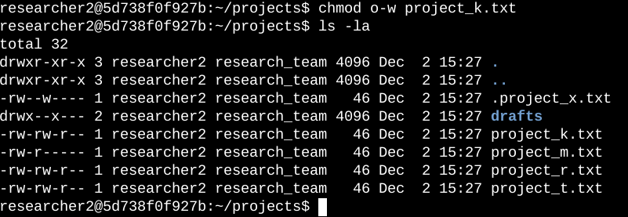

The first line of code is the Linux command I used to remove the write permission from *other*. The chmod command changes the permissions on files and directories. In this example, I removed the write permission of the project_k.txt file from *other* by entering o-w project_k.txt after chmod.

The second line outputs all the files in the projects directory and the permissions to them. I did this to check if the changes to the project_k.txt file went through.

## Change file permissions on a hidden file

The research team decided to archive the project_x.txt file and they do not want anyone to have write access to this project, but the user and group should have read access to this file. The following code demonstrates how I used Linux commands to change the permissions:

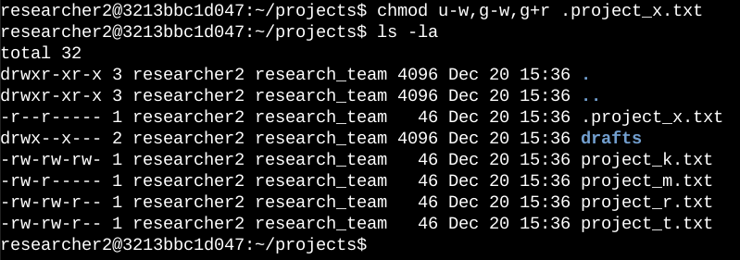

The first line of code is the Linux command I used to change the permissions to the project_x.txt file. I know from my previous permissions check using ls -la that the user has write permissions and the group has write permissions but not read permissions. I then use the chmod command following the removal of write permissions from user and group as well as granting group read permission to project_x.txt file. Since the file is hidden I know to add a period (.) before the file name when changing the permissions.

The second line outputs all the files in the projects directory and the permissions to them. I did this to check if the changes to the project_x.txt file went through.

## Change directory permissions

The organization determined that the researcher2 user should be the only one to have access to the drafts directory and its contents. This means that no other group or user should have any permissions in this directory.

The following code demonstrates how I used Linux commands to change the permissions:

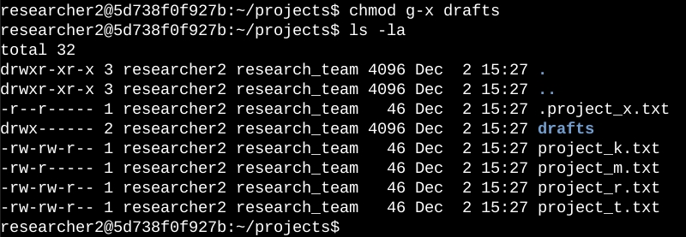

From my previous permissions check using ls -la I know that group has execute permission to the drafts directory so I need to remove it using chmod. While still in the projects directory I use the chmod command followed by g-x drafts to remove the execute permission to drafts from the group.

I then use the ls -la command to check that my permissions changes went through.

## Summary

I changed multiple permissions to match the level of authorization my organization wanted for files and directories in the projects directory. The first step was using ls -la to check the permissions for the directory. This command informed my decisions when changing permissions for different files and directories. I then used the chmod command multiple times to change the permissions on files and directories.